What are the Largest Christian Groups in the USA?

Part 1: The Big Picture
Christianity is the largest religion in the USA, but it is not one single group. It is made up of many different denominations (branches). These groups often share a belief in Jesus and the Bible, but they differ in how they worship, who leads them, and how they live their daily lives.
Task 1: Vocabulary Check
Using the text above and your own knowledge, define these two terms:
- Denomination: ___________________________________________________________
- Diversity: ________________________________________________________________
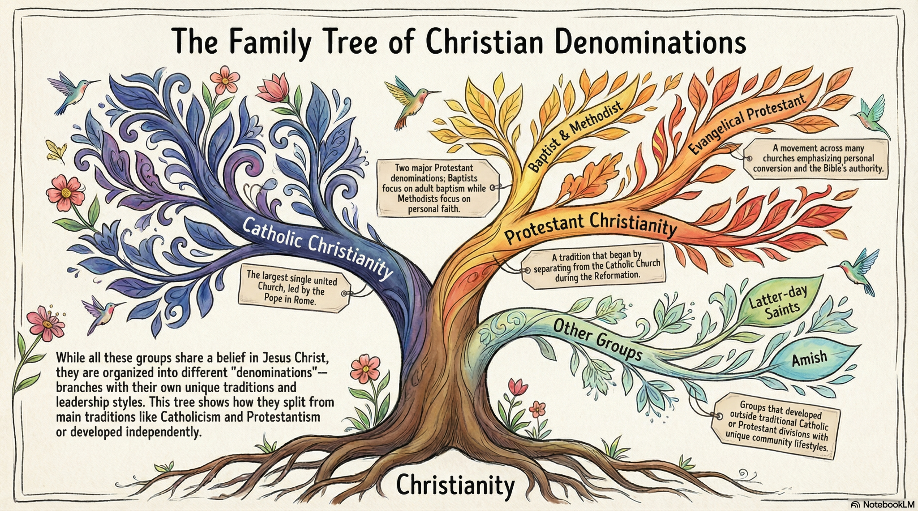

Part 2: Exploring the Groups
Read the information profiles below carefully.

A. Roman Catholics
- Beliefs: They believe the Catholic Church was founded by the first followers of Jesus. They believe in "Sacraments"—special rituals like baptism and communion that are believed to change the soul and provide God’s grace.
- Authority: They are led by the Pope in Rome. For Catholics, the Bible and "Church Tradition" (teachings passed down through history) are equally important.
- Worship: A structured service called the Mass. The most important part is the Eucharist (Communion).

B. Baptists
- Beliefs: A Protestant group that focuses heavily on the Bible. They believe the Bible is the only authority for faith.
- Baptism: They practice "Believer’s Baptism." This means only people old enough to choose for themselves are baptized, usually by being fully dipped under water.
- Authority: There is no Pope. Each local church is independent and makes its own decisions.

C. The Church of Jesus Christ of Latter-day Saints (LDS)
- Beliefs: They believe the original church of Jesus was lost and then "restored" in the 1830s. They follow the Bible but also the Book of Mormon.
- Lifestyle: They focus strongly on family. Many young people serve as missionaries. They follow a health code that avoids alcohol, tobacco, and caffeine.
- Authority: They believe in modern-day prophets who lead the church today.

D. The Amish
- Beliefs: They value humility and a simple life. They believe they should separate themselves from the modern world to focus on God.
- Lifestyle: They dress plainly, avoid modern technology (like cars and electricity), and support one another in close-knit communities.
- Worship: Simple services held in people’s homes rather than a church building.

E. Methodists
- Beliefs: They emphasize "social action"—the idea that faith should be shown by helping others and improving society.
- Lifestyle: They have a history of fighting for justice, such as helping the poor and working for fair laws.

Task 2: Comparison Table
Based on the reading, complete the table below.
Group | Key Authority (Who/What guides them?) | Unique Feature or Practice
Catholics
Baptists
LDS (Mormon)
Amish

Part 3: Deep Dive – Why do they differ?
One of the biggest differences between these groups is how they practice Baptism.
Catholic Baptism:
- Who: Babies.
- How: Water is poured over the head.
- Why: To welcome the baby into the Church immediately and receive God's grace from the start of life.
Baptist (Believer’s) Baptism:
- Who: Adults or older children.
- How: Full immersion (going completely under water).
- Why: To show that the person has personally chosen to follow Jesus.
Task 3: Analysis
- Why might a Baptist disagree with the practice of baptizing a baby?

- Why do you think the Amish choose to live without modern technology?

Part 4: Summary Reflection
Task 4: The Big Question
"Why don't all Christians express their religious tradition in the same way?" Use at least two different groups you studied today to explain your answer.

